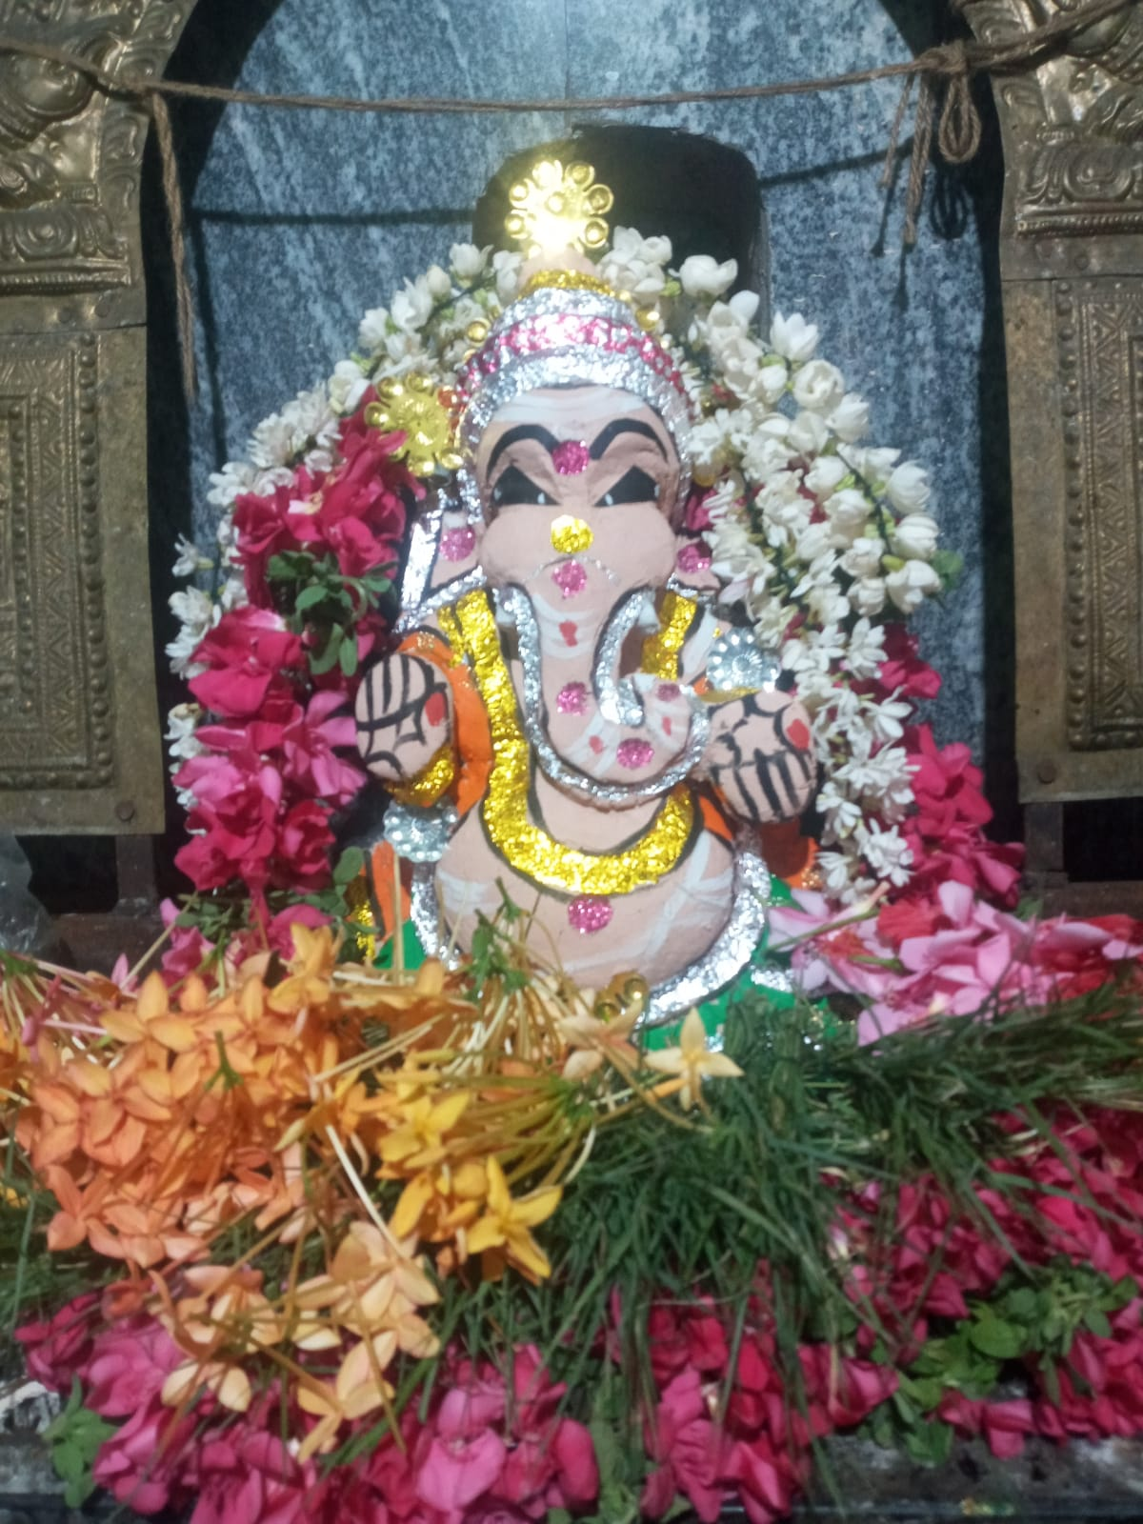
Raja Ganapathy Temple
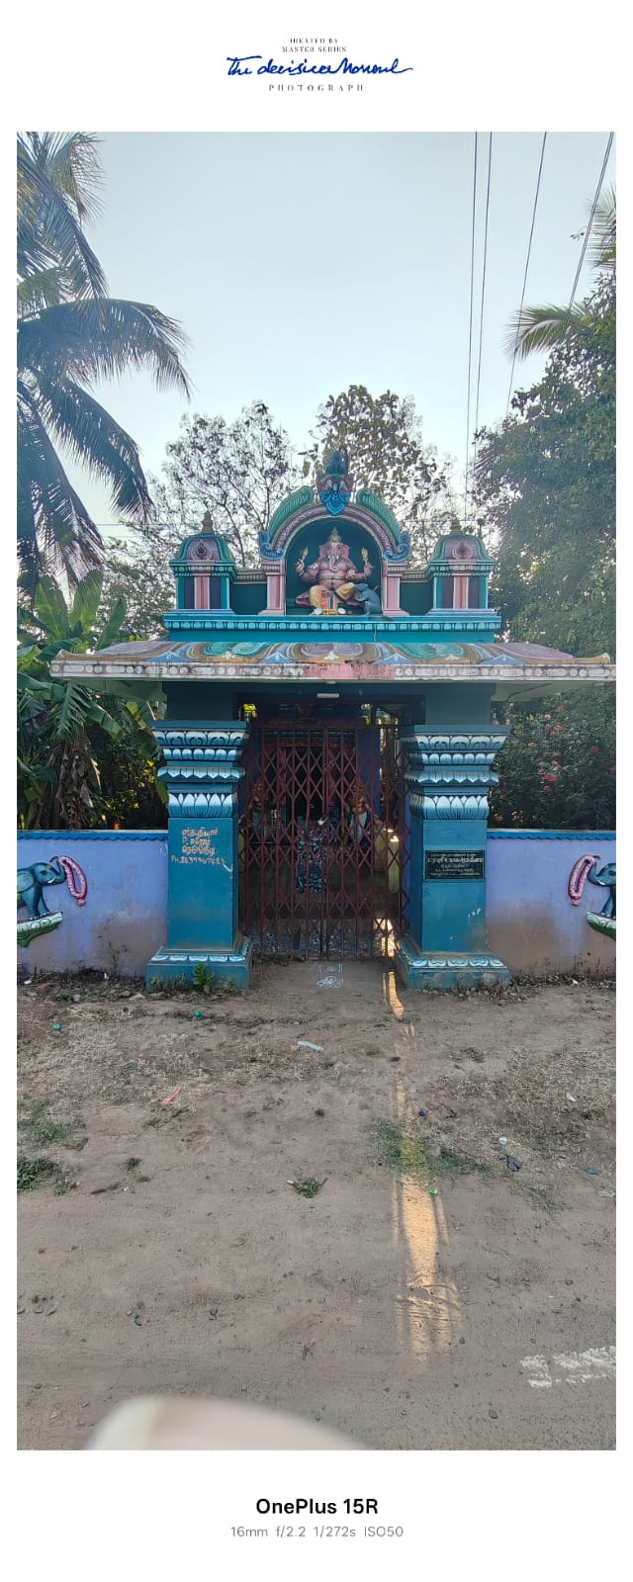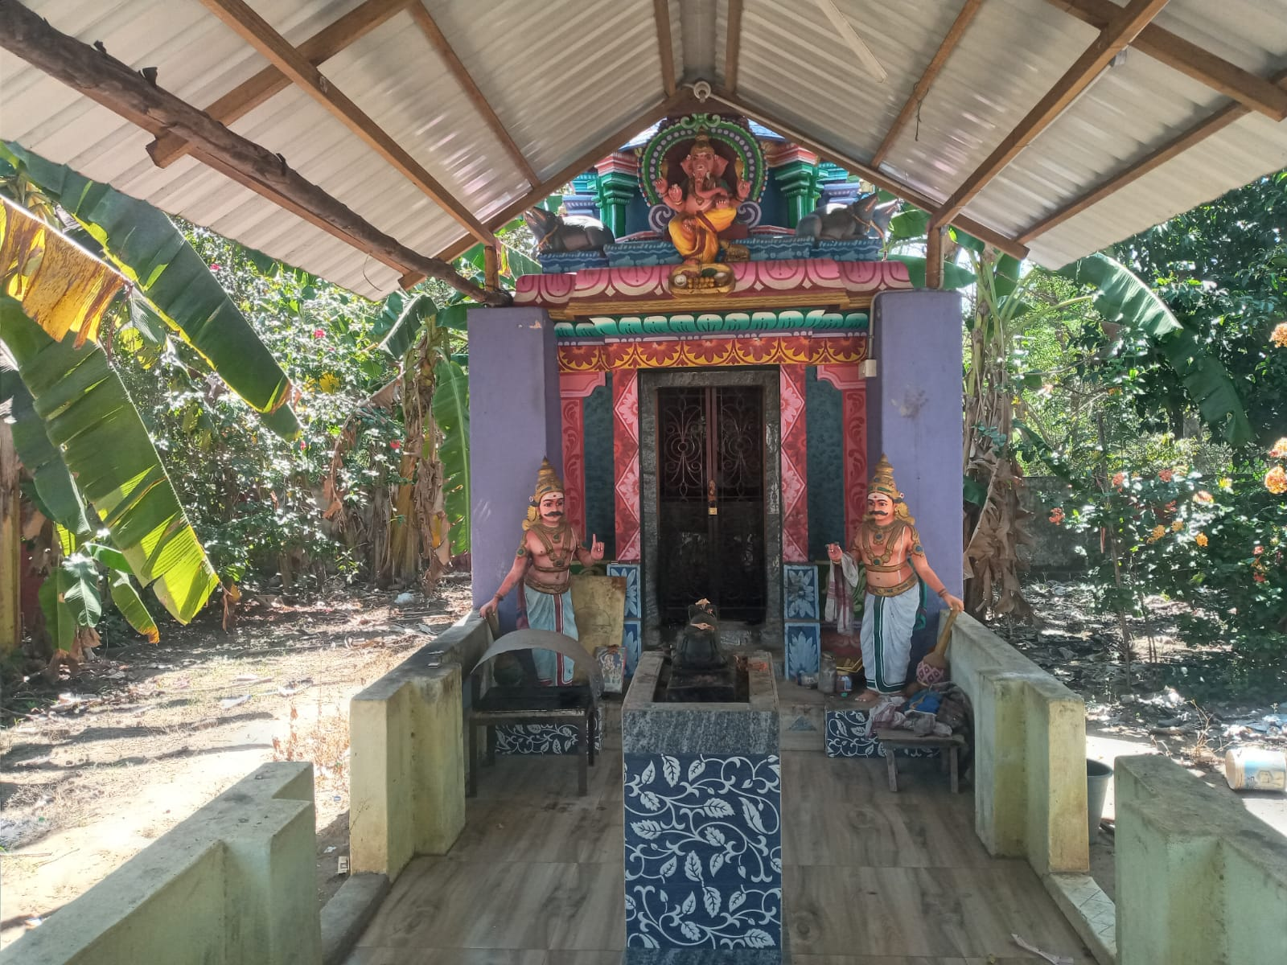

When we come from Adiyakkamangalam via Semangalam and cross Kaduvaiyaru river, you reach Kakkalany Bus stop. First thing you come across is this small beautiful temple called Raja Ganapathy Temple.
This is built and maintained by Mr Chokkalingam family.

